**Intelligent Systems**

**Exercise 6.** **Games and Adversary Search**

# Exercise description

The objective of this exercise is to practice the knowledge about the topic of games and adversarial search.

**Team members**

Write the student id, name, and campus of each member in a different line.

1: Carlos Hinojosa A01137566, Campus Monterrey

2: Eider Diaz A00828174, Campus Monterrey

3: Miguel Cortes A01270966, Campus Monterrey

MINIMAX with alpha-beta pruning

1. Find the **MINIMAX decision** in the following game tree by applying the minimax algorithm with alpha-beta pruning. In addition, it is expected that in the tree and for each interior node you show the MINIMAX value, the alpha value, and the beta value.

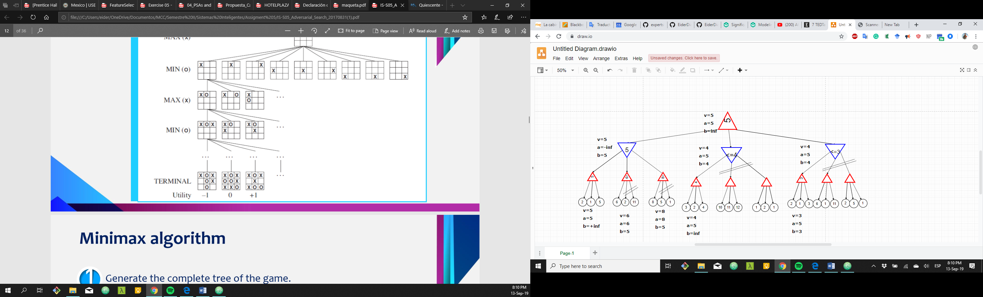

Nine men’s Morris

1. **Enumerate at least 3 relevant features of the game that can be used to construct the heuristic evaluation function for the game.**
2. The number of mills formed both by the player and the opponent (5 points each)
3. The number of “almost mills” (two pieces in mill position) prepared both by the player and the opponent (3 points each).
4. The number of total pieces in the board both belonging to the player and the opponent (1 point each).

The logic behind the decision of using these features is that a mill is very valuable due to them being immune to enemy attacks if there are still other pieces in the field not belonging to a mill; a mill can frequently also be “reused” for attacks by moving one of the pieces that forms it back and forth. Those pieces that are “almost mill” are also valuable because they are 1 piece away from forming a mill and taking one of the opponent’s pieces off the game. The total number of pieces is a very intuitive feature because one of the ways of reaching the end of the game is by leaving one player with only two pieces.

1. **Write a formula for your evaluation function**

The evaluation function for this heuristic takes the form:

With specific weights defined as follows:

Where:

* *f1* is the number of mills that the player has.
* *f2* is the number of mills that the opponent has.
* *f3* is the number of “almost mills” that the player has.
* *f4* is the number of “almost mills” that the opponent has.
* *f5* is the number of total pieces the player has remaining in the field.
* *f6* is the number of total pieces the opponent has remaining in the field.

1. **Evaluate the following boards using your evaluation function. Show the evaluation of each feature.**

**Board 1 Board 2**

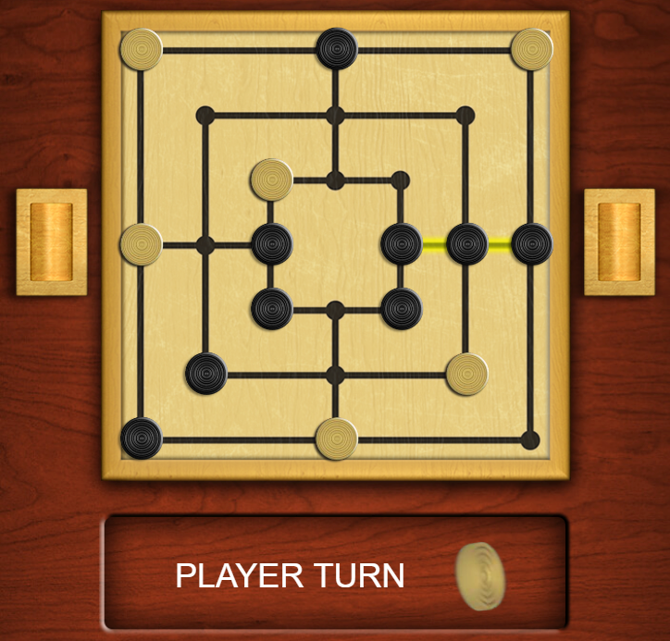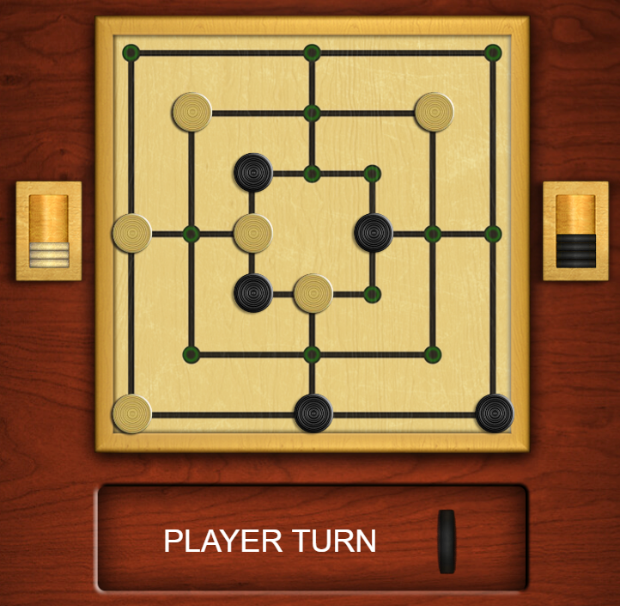

**Board 3**

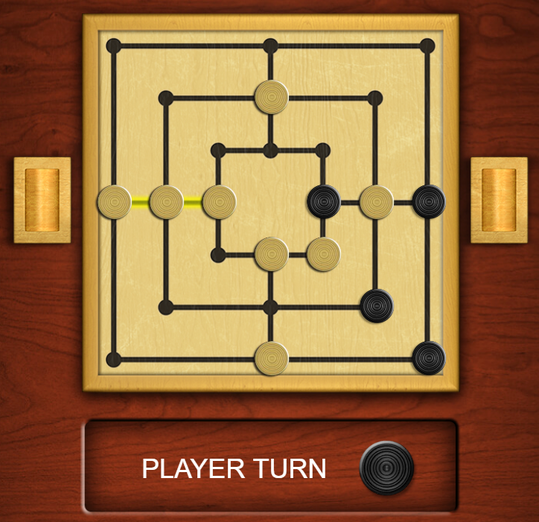

Board 1:

Board 2:

Board 3: